Mandatory Programming Assignment.
Tickets for a flight.

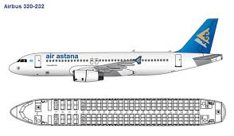

We have a flight with;
First class - 3 rows with each 4 seats row 1, 2 and 3 seat A,B,C and D
Business class - 21 rows (4 to 24), and 6 seats in each row named a, b, c, d, e, and f. Numbers of rows starts in the front of the flight.
You have to make at ticket system to handle where to place the passengers. You have always to know how many tickets sold, and how many available.
The flight has to be filled up from the middle (row 14), so that empty seats will be in front and back of the flight.
When a ticket is ordered, you fill in the name, and the seat number. When the plain are ready to take off you have to deliver a text file with all the passengers’ names and seat numbers.
The design and programming are all up to you.
Copy the Form1.cs file into a word document, include your full name and send it to my e-mail
jens@klarskovpedersen.dk before the 31 may at 23:59.

